I N T E R C U L T U R A L I N S T I T U T E

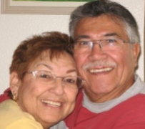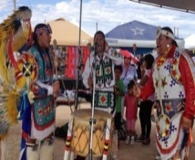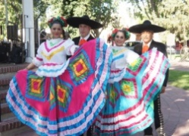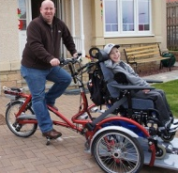

2017 CULTURAL CONSIDERATIONS & CULTURALLY INFORMED PRACTICES TRAINING
SIX (6) CONTINUING EDUCATION UNITS
MEETS SOCIAL WORKER and PEER SPECIALIST CULTURAL COMPETENCY REQUIREMENTS
COUNSELORS AND THERAPISTS QUALIFY FOR CEUs

LOCATION: NEW MEXICO HIGHLANDS UNIVERSITY ALBUQUERQUE CAMPUS
5041 Indian School Road NE Suite 100
Albuquerque, New Mexico 87110
(exit off I-40 south onto San Mateo Blvd then west on Indian School Road)

TRAINING OBJECTIVES: Gain knowledge of cultural & linguistic considerations, demographics & disparities in New Mexico. Learn effective practices and approaches in serving the diverse populations of New Mexico. Complete a cultural & linguistic self-assessment.

TRAINER: Fredrick Sandoval, MPA, Intercultural Institute, Cultural & Linguistic Competency Trainer

Trainings are held on SATURDAY as listed below from 8:30am-4:00pm at NMHU-Albuquerque

PLEASE CHECK BOX □ TO INDICATE THE SESSION YOU ARE REGISTERING* FOR:

□ August 19, 2017
□ October 21, 2017
□ November 18, 2017

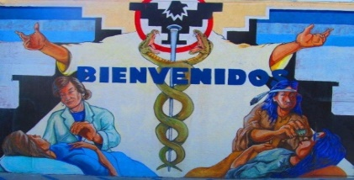
□ February 18, 2017
□ April 15, 2017
□ May 20, 2017
□ June 17, 2017

*REGISTRATION FORM - Please email your registration form to: intercultural.institute@gmail.com

DEADLINE: Please submit Payment and Registration by the TUESDAY before the scheduled training session.
NOTE: A $10.00 LATE REGISTRATION PROCESSING FEE WILL BE ASSESSED ON THE DAY OF THE TRAINING.

PLEASE PRINT
NAME (As you would like it to appear on the CEU): ________________________________________________________

MAILING ADDRESS: _________________________________________________________________________________

EMAIL ADDRESS:__________________________________________ Telephone #: _____________________________

TRAINING FEES: [ ] $120 - SOCIAL WORKERS, COUNSELORS, THERAPISTS
(Check one) (All levels of licensure, government, community provider & self employed, independent, private, for-profit and non-profit)
[ ] $60 - PEER SPECIALISTS AND SOCIAL WORK STUDENTS

MAIL CHECK OR MONEY ORDER PAYABLE TO: FREDRICK SANDOVAL, 6555 ROBIN, COCHITI LAKE, NM 87083
No purchase orders accepted. For more information email intercultural.institute@gmail.com; text or call 505.660.0373, 505.980.5156

