 | STATE OF NEW MEXICO  REAL ESTATE COMMISSION  5500 San Antonio Dr. NE Suite B  Albuquerque, NM 87109  (505) 222-9820 |  |  |  |  | 
INSTRUCTOR APPLICATION |  |  |  |  |  | Date
Name:  Home address:  Work address:  [ ] I currently am an Instructor for other NMREC approved courses.  [ ] I am a new instructor candidate. |  |  |  | Home Phone:  Work Phone:  Fax #:  Email:
As an instructor candidate I will comply or have complied with the following criteria:

[ ] I have attended an instructor training course, Core Course Instructor Boot Camp, or will attend a suitable Instructor Development Workshop within one year of being approved. A certificate is attached or will be sent when competed to the Education Administrator.

[ ] I am prepared to make a 15-60 minute presentation before the Education Advisory Committee in the courses I am
planning to teach. I am prepared to answer questions about the subject matter. Although not encouraged, applicants may
present using suitable distance technologies.

[ ] I understand that I will be judged on my subject matter expertise, my command of the proposed material, my overall
ability to communicate the material interactively to an audience, and my general adherence to the Generally Accepted Principles of Education among other accepted educational standards.

[ ] I agree to comply with the Anti-Harassment and Non-Solicitation Policy (Attached) in the instruction of any course for which I am approved.

Course(s) I propose to teach
Prelicensing Course(s) [ ]  [ ] Principles and Practices  [ ] Real Estate Law  [ ] Broker Basics (must be approved to teach RE P&P and RE Law)  [ ] Brokerage Office  Administration  [must have two years’ experience as a qualifying broker in New Mexico or another licensing jurisdiction.]  [ ] Within 6 mos. prior to this application, I have passed the brokers examination with a minimum score of 84%. |  | Core Course [ ]  [ ] I am an applicant candidate to be a Core Course Instructor and understand I must comply with all the steps in the Core Course Roadmap approved by the NMREC (attached) | QB Refresher Course [ ]  [ ] I am approved to teach Principles and Practices, Real Estate Law, and Broker Basics;  And,  [ ] I am a Qualifying Broker or have a QB License but acting as an AB;  Or,  [ ] I was approved to teach NMREC Mandatory Course or  Am approved as a Core Course Instructor. |  | New Broker Business  Practices [ ]  [ ] have two years’ experience as an active qualifying broker with supervisory responsibilities; or two years actively licensed as an associate broker and served as a trainer for a brokerage, or two years actively licensed as an associate broker and am approved as a continuing education instructor of other NMREC courses.  [ ]New Course  [ ] Existing Course  Title/Number:  [ ] I have complied with all the rules set forth in 16.61.15.11.A(1) – (3)  [ ] I am seeking permanent ZOOM or other live/distance method approval on a permanent basis. [You will be evaluated on your abilities to navigate the live/distance platform in addition to course subject matter expertise.]
Sponsor(s) for whom I will instruct: Address:

____________________________________________ _________________________________________________

____________________________________________ _________________________________________________

____________________________________________ _________________________________________________

(add separate sheets if necessary)

Education Experience – list all education experience which is applicable to the position for which you are applying. Include college programs, any licensee training programs, apprenticeships, real estate designations, etc.

Dates(from/to) Educational Institution(s) Degree, Diploma, License,
Award, Etc.

______________ ________________________________________________________ __________________________

______________ ________________________________________________________ __________________________

______________ ________________________________________________________ __________________________

(add separate sheets if necessary)
Occupational Experience – list all employment experience accumulated during the past 10 years.

Dates Employed by Job Title

______________ _________________________________________________________ __________________________

______________ _________________________________________________________ __________________________

______________ _________________________________________________________ __________________________

______________ _________________________________________________________ __________________________

(add separate sheets if necessary)
Teaching Experience – list the teaching experience you have had (public and/or private school, military, industrial, etc.) which is applicable to the positions for which you are applying:

Dates (from/to) Employed by Subject taught

______________ ________________________________________________________ ___________________________

______________ ________________________________________________________ ___________________________

______________ ________________________________________________________ ___________________________

(add separate sheets if necessary)

References – entities for whom you have taught a similar course(s)

1. Name___________________________________________ Address_______________________________________

Phone_______________________ Association with Applicant_________________________

1. Name___________________________________________ Address_______________________________________

Phone_______________________ Association with Applicant_________________________

1. Name___________________________________________ Address_______________________________________

Phone_______________________ Association with Applicant_________________________

[ ] I have attached a Resume. [ ] I understand that a $75 application fee
Will not be due until after notification of approval by the NMREC.

If licensed as a New Mexico broker, give date of initial licensing:

Associate Broker ____________

Qualifying Broker ____________

License # _________________

I attest to having qualities of honesty, integrity and trustworthiness. I have not had any real estate license or instructor certification revoked or suspended, nor had a real estate license or instructor certification renewal denied by any regulating entity of any state. I have not been convicted of nor entered a plea of “nolo contendere” to any criminal offense involving moral turpitude. I have not had any civil judgment entered against me based on fraud, misrepresentation or deceit.

I attest that the information provided on this application and all attachments is, to the best of my knowledge, true and correct. I also agree to abide by the administrative rules as outlined in Title 16 Chapter 61 Part 15.

____________________________________________________________
Signature of Director/Responsible Party Date

Sworn to and subscribed before me this____ day of ____________, 20___________.

_______________________________________
NOTARY PUBLIC

My commission expires: _________________

INSTRUCTOR REQUIREMENTS

- All instructors teaching real estate courses shall have been approved by the commission prior to teaching a course.
- The candidate must complete and submit to the commission an application for commission review.
  - Either One hard copy original no less than 30 days prior to the Education Advisory Committee meeting when the candidate would like to present their application in person. (Meeting dates are posted at www.state.nm.us/nmrec then click on EDUCATION!)
  - OR one electronic copy of the application via e-mail to the Education Administrator at Thomas.baca@state.nm.us in .pdf format, no less than 30 days prior to the Education Advisory Committee meeting when the candidate would like to present their application in person. (Meeting dates are posted at www.state.nm.us/nmrec then click on EDUCATION!)
- All instructor candidates shall complete a commission-approved instructor-training course or NMREC Instructor Development Workshop within one year of being approved as an instructor and every three years thereafter. Instructors who fail to submit documentation of completion of the instructor-training course will be de-certified.
- All instructor candidates must have high integrity, and be honest, truthful, reputable and competent.
- Instructor candidates must be prepared to make a minimum 15 - 60 minute presentation to the Education Advisory Committee, exhibiting their teaching skills and knowledge of the subject matter.
- Candidates shall be prepared to answer questions about the subject matter they are seeking approval to teach. Presentations shall be audiotaped or videotaped and the tapes will be retained for a period of three months for commission review.
- The candidate may bring notes, books, etc. to support the oral presentation before the committee but may not use the notes on the oral exam. The candidate must bring 14 copies of any student materials (not to include the course outline previously submitted). The materials will be distributed to Education Advisory Committee, and the Education Administrator.
- Candidates must use NMREC approved course outlines for courses previously approved by NMREC. Candidates and approved instructors may be required by NMREC to update approved course outlines although they will remain the property of NMREC.
- The presentation shall conform to the Generally Accepted Principles of Education as proposed by the Real Estate Educators Association. (Attached)
- The commission shall grant or deny instructor approval based on this presentation.
- If the application is denied a recommendation for approval by the Education Advisory Committee, a written notice to the candidate from the NMREC Education Administrator will provide specific reasons. Candidates may present the same course to the Education Advisory Committee a maximum of 2 times per 12-month period of time. If the Education Advisory Committee fails to recommend, the denial may be appealed to the Real Estate Commission during the Public Forum section of their meeting.
- An approved instructor shall comply with the following requirements:
  - Conduct all classes in accordance with commission rules and education policies.
  - Ensure that all instruction is free from misrepresentation.
  - Instruct in accordance with commission approved course content requirements.
  - Ensure that all instruction is free harassment, bullying and non-solicitation.
  - Allow access to any approved class to any duly appointed representative of the commission.
  - Certify to the sponsor a true and correct record of student attendance.
Generally Accepted Principles of Education
Adopted by The REEA Board of Directors*
KNOWLEDGE  Instructors should:  1. Provide current information  2. Present alternative viewpoints on material when there is not a single position that is accepted industry wide  3. Clearly identify opinions as the instructor’s opinions  4. Build a proper foundation for each major element of a subject  5. Deal with all key elements of a subject  6. Cover the material adequately in the allotted time  7. Answer all questions logically and concisely  8. Be informed enough to handle a variety of questions on the subject being taught  9. Admit when he/she does not know the answer to a question and volunteer to obtain the information  10. Focus on students gaining knowledge, not on impressing the students with the instructor’s knowledge  ANDRAGOGY (Adult Learner)  Instructors Should:  1. Present new ideas by relating them to pre-existing knowledge held by the learners  2. Teach at the learners level  3. Show in a specific way how new material will benefit learners  4. Encourage questions and motivate involvement  5. Show tolerance—both to ignorance and disagreement, thus avoiding arguments and confrontation  6. Build learner’s self-esteem  7. Call learners by name  8. Involve learners in the learning process through planned activities  9. Use a variety of teaching methods  10. Teach to all participants, not just to those who show interest  11. Present key points by using examples as illustrations  SPEECH  Instructors Should:  1. Use concise, simple, and normal speech patterns, use simple terminology  2. Not read to the class  3. Keep the presentation on pace thus finishing the material in the allotted time  4. Keep the topic flowing  5. Speak loudly enough to be heard by all  6. Enunciate clearly without being overdone  7. Restate an individual learner’s questions to the group as a whole prior to attempting to answer the question  8. Use humor when appropriate to make a point  *Revised 1994 | TEACHING AIDS  Instructors Should:  1. Make sure materials are legible, correctly spelled, properly numbered and mechanically produced using readable typeface  2. Use visual imagery when possible to enhance written words  3. Use written words when possible to enhance oral speech. NOTE: Written is better than oral; visual is better than written  4. Follow the prepared outline  5. Make sure that all material on the outline will be covered in the class and none of it is extraneous  6. Deviate from prepared material only to meet specific needs  7. Arrange the classroom so that learners do not have to look through physical objects  8. Use modern presentation equipment such as overhead projector or computer projection  9. Use equipment that enables the instructor to remain looking at the learners rather than turning back to the class to write  10. Make sure that the physical stature of the instructor does not block the view of the learners toward the projected material  11. Make sure that the projector screen is easily visible to the group as a whole  12. Use color  13. Use large images for projected material  14. Turn the projected image off when not in use and on to recall attention to the material  15. Never block the image by walking between the  projector and the screen with the projector on  LEARNING ENVIRONMENT  Instructors Should:  1. Be positive toward the subject matter  2. Refrain from ridiculing either the learners or others  3. Wear professional attire  4. Attend to personal grooming  5. Set up the room to accommodate the approximate number of learners expected to attend  6. Make sure to keep empty seats at a minimum  7. Make sure that a lectern or table at front of room is unobtrusive  8. Provide writing surfaces for learners  9. Make sure that learners have ample space between seats  10. Not stand behind physical objects for more than a short time period  11. Use gestures during the presentation  12. Use physical movement during the presentation to minimize the physical distance between the instructor and learners and try to involve all learners equally

Knowledge | - Focus on students gaining knowledge, not on impressing the students with instructor’s knowledge.
Speech | - Concise, simple and normal speech patterns.  - Not read to the class. Stay on pace, Speak loudly enough to be heard.  - Use humor when appropriate to make a point.
Andragogy | - Present key points by using examples as illustrations.  - Teach at the learner’s level.  - Show in a specific way how new material will benefit the learner.  - Call learners by name.  - Encourage questions and motivate involvement.  - Teach to all participants, not just to those who show interest.
Learning Environment | - Be positive toward the subject matter. Be professional attired and groomed. Use gestures during the presentation.
Teaching Aids | - Make sure materials are legible, correctly spelled, properly numbered, and mechanically produced using readable type face. Use written word when possible to enhance oral speech. (Note: written is better than oral; visual is better than written).  - Follow the prepared outline.  - Deviate from prepared material only to meet specific needs.  - Use color.  - If using a projector, make sure image is visible to the group, turn projector off when not in use, never block image by walking in front of projected image.

Learning Level | BLOOM’S TAXONOMY
6 | Evaluation: appraise, argue, assess, attach, choose, compare, defend, estimate, judge, predict, rate, core, select, support, value, evaluate.
5 | Syntheses: arrange, assemble, collect, compose, construct, create, design, develop, formulate, manage, organize, plan, prepare, propose, set up, write.
4 | Analysis: analyze, appraise, calculate, categorize, compare, contrast, criticize, differentiate, discriminate, distinguish, examine, experiment, question, test.
3 | Application: apply, choose, demonstrate, dramatize, employ, illustrate, interpret, operate, practice, schedule, sketch solve, use, write.
2 | Comprehension: classify, describe, discuss, explain, express, identify, indicate, locate, recognize, report, restate, review, select, translate.
1 | Knowledge: arrange, define, duplicate, label, list, memorize, name, order, recognize, relate, recall, repeat, reproduce, state.

 | STATE OF NEW MEXICO  REAL ESTATE COMMISSION  5500 San Antonio Drive NE Suite B  Albuquerque, New Mexico 87109  (505) 222-9820
ANTI-HARASSMENT AND NON-SOLICITATION POLICY

The New Mexico Real Estate Commission is committed in all areas to providing an instructional environment that is free from harassment. Harassment based upon an individual's sex, race, ethnicity, national origin, age, religion or any other legally protected characteristics will not be tolerated. Any instructor certified by the New Mexico Real Estate Commission and instructing a qualified pre-licensing or continuing education course, including sponsors and sponsor’s employees/vendors, are expected and required to abide by this policy. No student or course attendee will be adversely affected as a result of bringing complaints of unlawful harassment.
Sexual harassment is behavior of a sexual nature that is unwelcome and offensive to the person or persons it is targeted toward. Examples of harassing behavior may include unwanted physical contact, foul language of an offensive sexual nature, sexual propositions, sexual jokes or remarks, obscene gestures, and displays of pornographic or sexually explicit pictures, drawings, or caricatures

Reporting Harassment
If a pre-licensed student or licensee attending any real estate course approved by the New Mexico Real Estate Commission feels that he or she has been harassed on the basis of his or her sex, race, national origin, ethnic background, or any other legally protected characteristic, or believes he or she has been a target of sexual harassment, they should immediately report the matter to the New Mexico Real Estate Commission Education Administrator. If that person is not available, or if the student or licensee feels it would be unproductive to inform that person, the student or licensee should immediately contact the New Mexico Real Estate Commission Executive Director. Once the matter has been reported it will be promptly investigated and any necessary corrective action will be taken where appropriate. All complaints of unlawful harassment will be handled in as discreet and confidential a manner as is possible under the circumstances.

Non-Solicitation of Licensees
Any instructor certified by the New Mexico Real Estate Commission and instructing a qualified pre-licensing or continuing education course, or the sponsor of that course and/or instructor, will not, directly or indirectly, approach, solicit, entice or attempt to approach, solicit or entice any of their course attendees to leave the brokerage with whom the licensee is associated, either during the instructional period or subsequently through information gained by the instructor through the pre-licensee’s or licensee’s registration for the course.

Corrective Action
Any instructor or sponsor found to be engaging in improper harassing behavior or solicitation will be subject to disciplinary action, including the possible termination of instructor or sponsor status with the New Mexico Real Estate Commission.
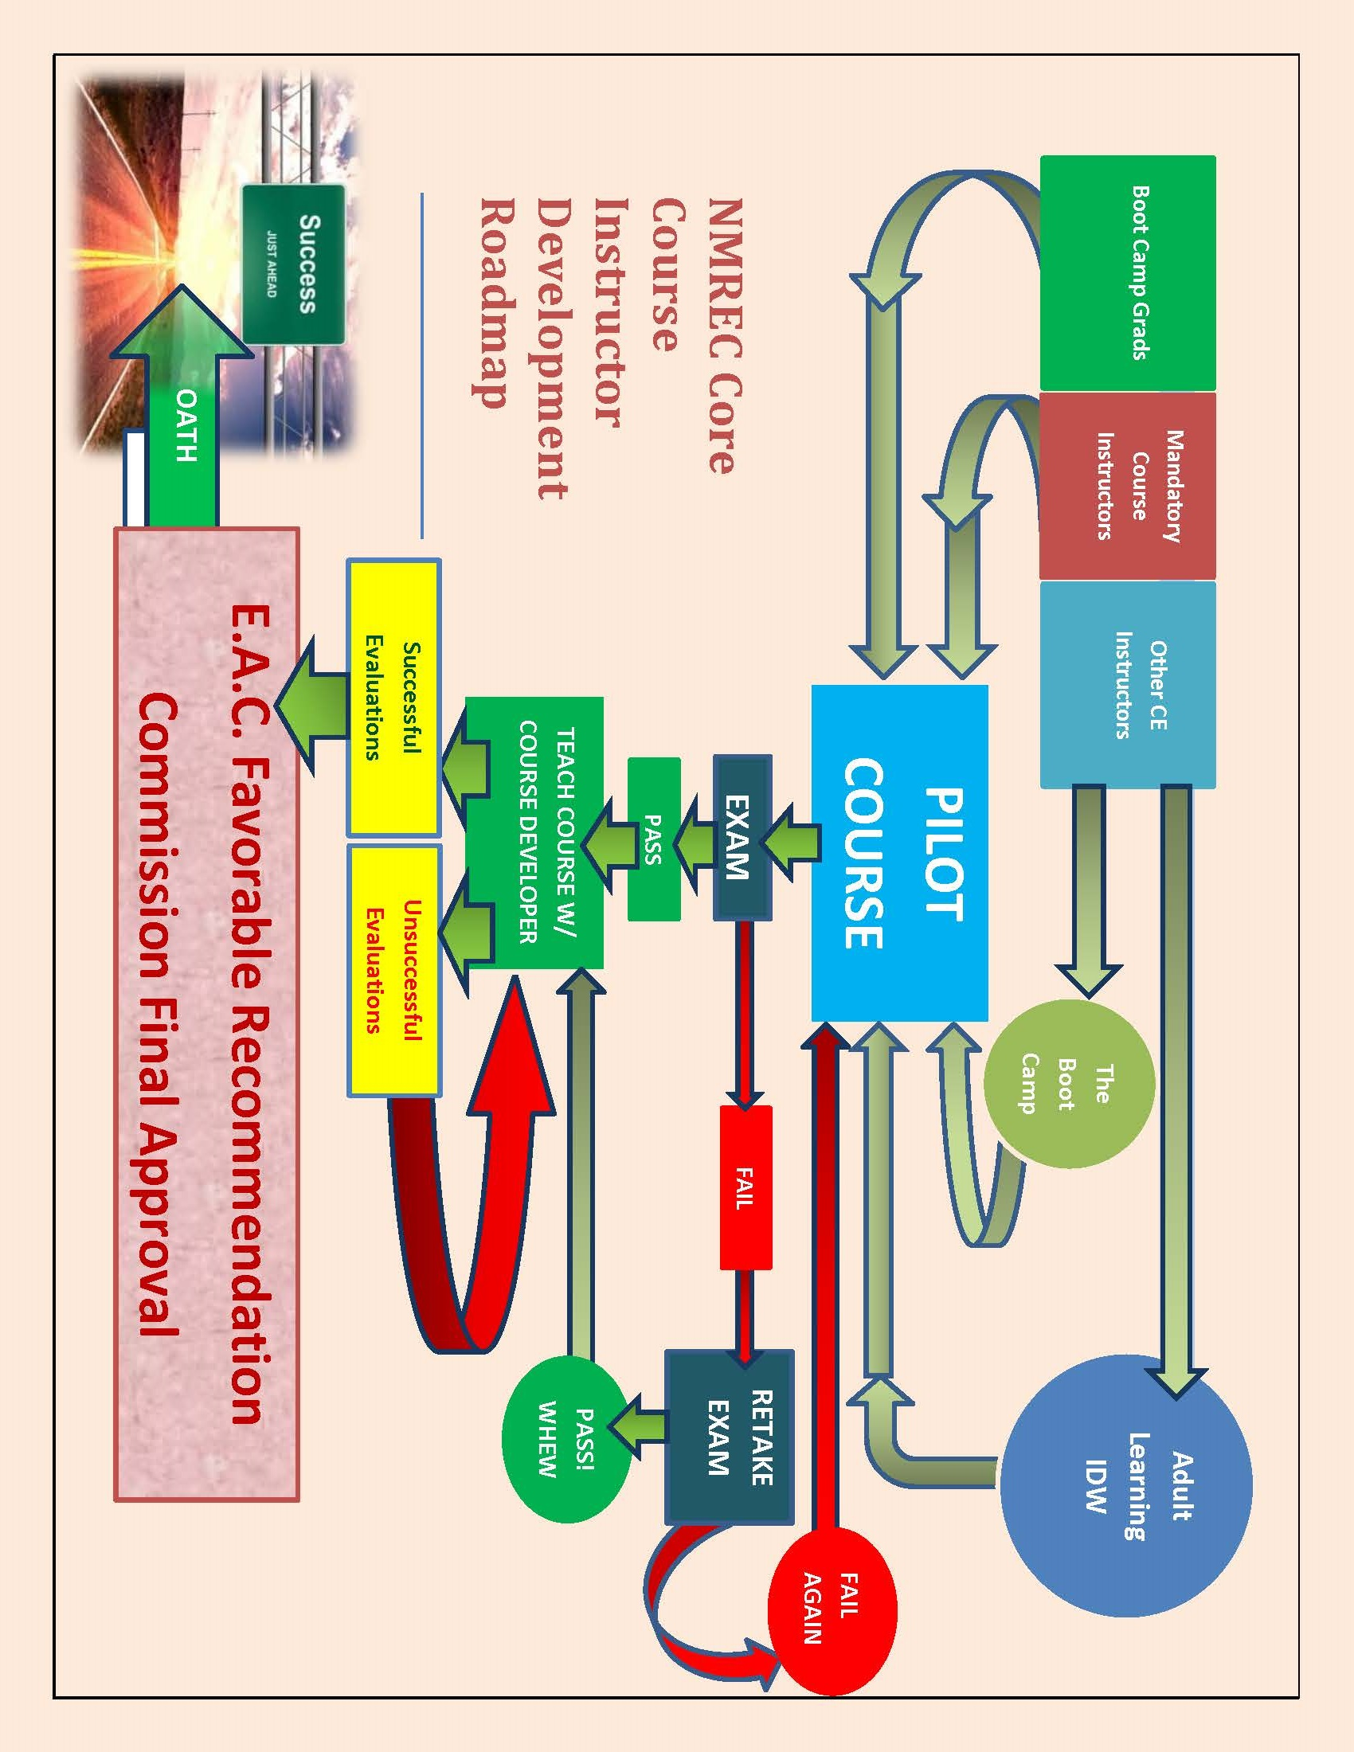

Bloom’s Taxonomy was used by REEA when developing the Generally Accepted Principles of Education and remains an important tool NMREC instructors use when preparing and presenting courses. (Chart Attached)

