CYBERSECURITY BEST PRACTICES FOR CONSUMERS
Tips To Help Protect Consumers Against Cybercrime
National Cyber Security Awareness Month 2015

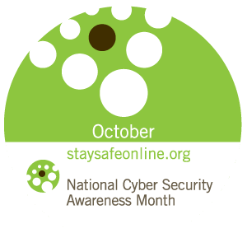
National Cyber Security Awareness Month (NCSAM), celebrated every October, was created as a collaborative effort between government and industry to ensure every American has the resources they need to stay safer and more secure online.

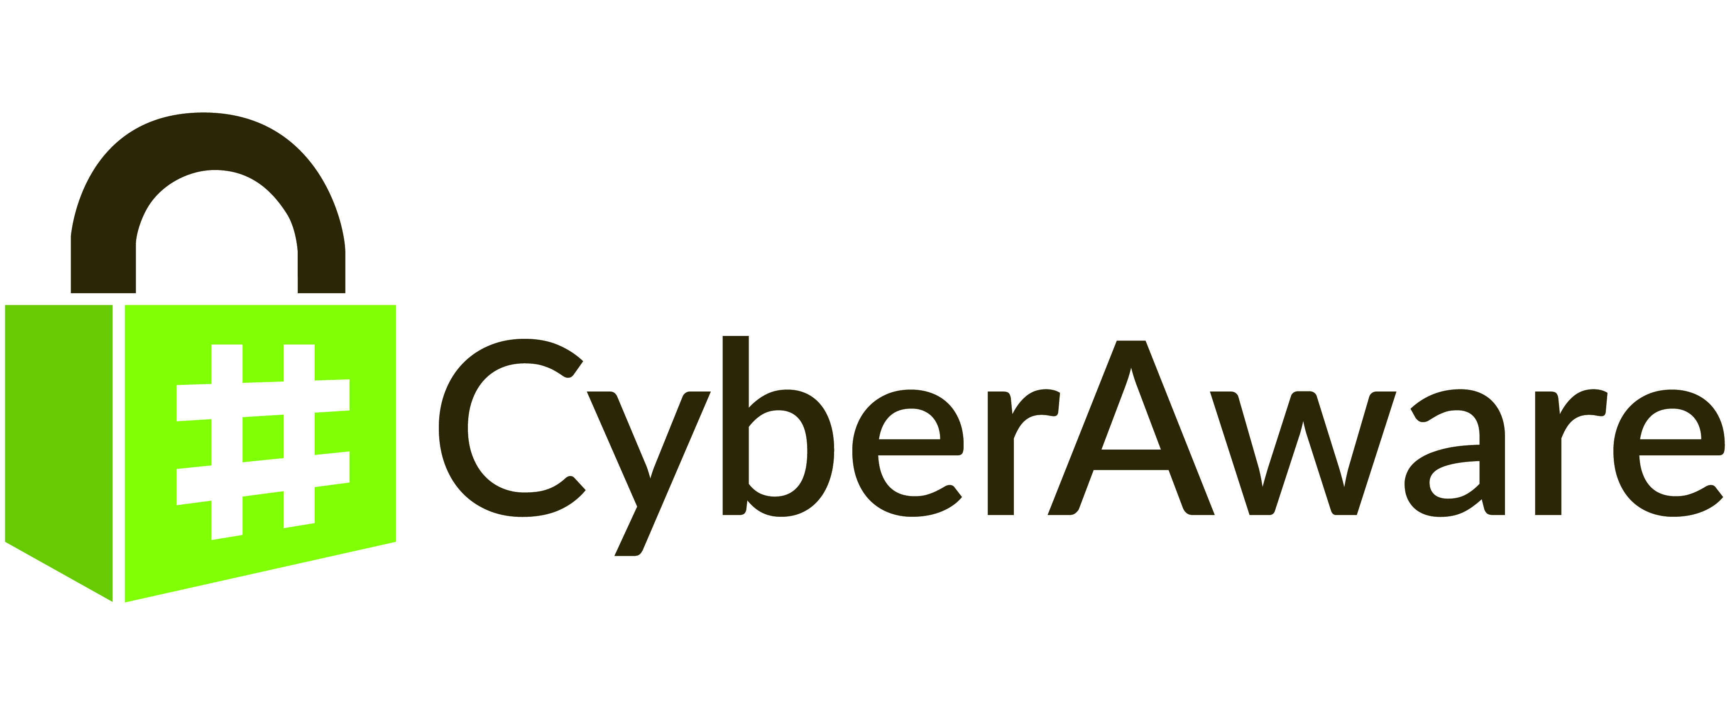

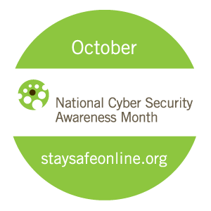
KEEP A CLEAN MACHINE
Having the latest security software, web browser, and operating system are the best defenses against viruses, malware and other online threats.

PROTECT ALL DEVICES THAT CONNECT TO THE INTERNET
Along with computers, your smartphones, gaming systems and other web-enabled devices also need protection from viruses and malware.

PROTECT YOUR CHILD’S PERSONAL INFORMATION
When available, set your child’s privacy and security settings on websites to your comfort level for information sharing. Remind them that it’s OK to limit how and with whom they share information.

TREAT YOUR PERSONAL INFO LIKE CASH
Don't hand it out to just anyone who asks. Your Social Security number, credit card numbers, and bank account numbers can be used to steal your money or open new accounts in your name. So every time you are asked for your personal information -- whether in a web form, an email, a text, or a phone message -- think about whether you can really trust the request.

STRONG, UNIQUE PASSWORDS
Combine capital and lowercase letters with numbers and symbols to create a more secure password. Additionally, having separate passwords for every account helps to thwart cybercriminals.

BE WEB WISE
Think before you act. Be wary of communications that implores you to act immediately, offers something that sounds too good to be true, or asks for personal information.

CYBERSECURITY BEST PRACTICES FOR CONSUMERS
Tips To Help Protect Consumers Against Cybercrime
National Cyber Security Awareness Month 2015

National Cyber Security Awareness Month (NCSAM), celebrated every October, was created as a collaborative effort between government and industry to ensure every American has the resources they need to stay safer and more secure online.

WHEN IN DOUBT, THROW IT OUT
Links in email, tweets, posts, and online advertising are often the way cybercriminals compromise your computer. If it looks suspicious, even
if you know the source, its best to delete or if appropriate, mark as
junk mail.

SHRED IT
Shred sensitive papers like receipts, banks statements and unused
credit card offers before throwing them away.

USE ONLINE BANKING TO PROTECT YOURSELF
Monitor your financial accounts regularly for fraudulent transactions.
Sign up for text or email alerts from your bank for certain types of transactions.

BACK IT UP
Protect your valuable work, music, photos, and other digital
information by making an electronic copy and storing it safely.

